Contra Costa County Department of Ag and CDFA, Egg Safety and Quality Management Program invite you to join us for an outreach and educational workshop!

When:
Tuesday November 14th, 2017 10:00am – 3:00pm
Where:
Contra Costa County Department of Ag, 2366-A Stanwell Circle, Concord CA 94520
Who Can Attend:
Anyone producing eggs or anyone interested in producing eggs
What:
Info for Egg Producers, Intro to Chickens, Biosecurity, Hands on Candling Exercise, Poultry Disease, Egg Quality

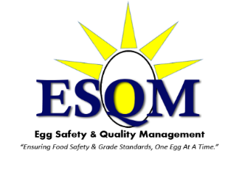
RSVP: (916) 900-5090 by Nov 9, 2017
Please RSVP to receive take home materials and Certificate of Completion.
Drop in’s welcome upon available space.

